**Human Growth and Development**

[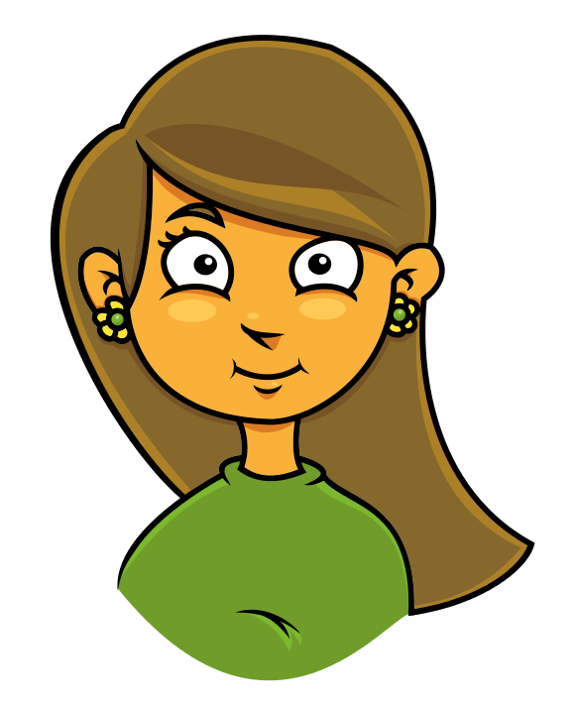](http://www.google.com/url?sa=i&rct=j&q=girl+clipart&source=images&cd=&cad=rja&uact=8&ved=0CAcQjRw&url=http://toplowridersites.com/clipartist-clip-art-girl-face-cartoon-openclipart/&ei=Icq2VNWJC8GHsQTOtILYAg&bvm=bv.83640239,d.cWc&psig=AFQjCNFGu-U3KxavE8Ul65PF5BlKzLGsEw&ust=1421351782397023)

5th Grade Girls

Student/Parent Packet

Central Bucks School District

**Overview of the Female Reproductive System**

Understanding the reproductive system is as important as understanding any other organ system of the body. Encourage students to learn this system and understand the function of each part. By becoming familiar with the female anatomy, girls can better grasp what happens during the menstrual cycle. Require that they learn the correct terminology as well. Review pronunciation. Help students understand the approximate location, size and shape of each organ.

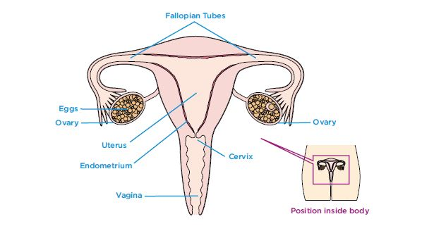

**Cervix** – The base of the uterus with a small opening between the uterus and vagina.

**Egg** – Also called an ovum; the female reproductive cell.

**Endometrium** – Spongy, blood-filled tissue that lines the uterus and nourishes a developing embryo. Discharged during menstruation.

**Fallopian tubes** – Two tubes connecting the ovaries to the uterus through which the egg travels.

**Ovaries** – Two glands, one on either side of the uterus, that contain a woman’s egg cells and produce estrogen, progesterone and other hormones.

**Ovulation** – Moment at which an egg is released from an ovary.

**Urethra** – Tube that carries urine from the bladder out of the body.

**Uterus** – Also called the womb, a muscular organ, lined with soft, nourishing tissue that carries the fetus until birth.

**Vagina** – The flexible passageway leading from the cervix to the outside of the body. Menstrual fluid flows through the vagina.

Educators and students can find more terms and definitions at

**Physical changes at puberty for girls**

The female stages of development are typically described by the five Tanner stages of breast development and pubic hair growth, along with other signs of female maturation: the growth spurt, the onset of vaginal discharge, and the start of menstruation. The drawing below describes these five stages with average age ranges.

It is important to emphasize that each girl's progression through the stages will be slightly different according to her own body's timetable.

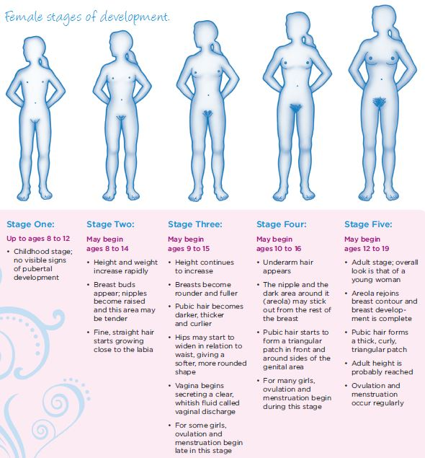

UNIT I Calendar Activity

Jane keeps a record of when her periods begin and end. This helps her know approximately what day to expect her next period. She is aware that her menstrual cycle will not be exactly the same from month to month. She also knows that her cycle is not the same as anyone else’s cycle, because each person is totally unique. Read the descriptions of when Jane's periods began and how long they lasted. Then, mark the calendar by circling each day her period began and drawing a line through the remaining days in each period.

Her period began on June 9th and lasted three days.

Her next period started on July 1Oth and lasted five days.

In August, Jane took a trip with her parents. All of. The excitement caused her period to be delayed.

She got her period again on September 1st and it lasted four days.

It came again on September 30ih and lasted five days.

Her next period began on October 31st and lasted five days.



**A**. Count the number of days in each menstrual cycle (beginning with the first day of Jane's period and ending with the day before her next period.)

1. ------ 2. ------ 3. ------4. ------

**B**. About when should Jane expect to get her next period? ------------

c. How many days is her next period likely to last? --------------

**Unit II**

**Quiz-Female Puberty**

Fill in the blanks using the words listed below.

Estrogen Pubic Hair Uterus

Period Ovaries Body Fat

1. An increase in ___________________ causes the hips and other parts of the body to become rounder.
2. During puberty __________________ begins to grow in the genital area.
3. The hormone _________________ causes changes to begin to take place in a girl’s body.
4. The group of days during menstruation is called the ____________________.
5. Every month or so, an egg cell is released by one of the ______________ found inside a girl’s body.
6. The lining of the ___________________ breaks up and leaves the body as menstrual flow.

Circle the answer that best completes the following statements.

1. The four tallest students in Mrs. Smith’s 5th-grade class are girls. This may be because:
   1. Only the shortest boys are allowed in the class.
   2. Girls usually begin their growth spurt earlier than boys.
   3. Mrs. Smith is the girls’ basketball coach.
   4. The girls did stretching exercises to grow faster.
2. Once Janet reached puberty, her daily hygiene habits changed. Now she does all of the following EXCEPT:
   1. Bathe every day
   2. Wear deodorant
   3. Get plenty of rest
   4. Eat a lot of sweets
3. Gayle, Lynn, and Sue are best friends. Gayle had her first period when she was 10. Lynn had hers at age 12. Sue, who is almost 14 hasn’t had a period yet. Which of these girls is normal?
   1. Lynn
   2. Gayle and Lynn
   3. Sue and Gayle
   4. All of them
4. Laura has noticed some changes in her body. Her teacher said that these changes happen when girls reach puberty, and they include all of the following EXCEPT:
   1. A rash on the shoulders and arms
   2. Growth of the breasts
   3. Hair in the pubic area and under the arms
   4. A rounder shape in the hips and thighs